Module Code: | SM0382
Module Title: | Strategic Management & Corporate Social Responsibility

Assessment 1

The overall assessment of the module has two components:

Component 1 comprises 20% of the overall marks:

- An individual assignment that includes an analysis and evaluation of an industry’s macro business environment. The report should have a length of approximately 800 words (excluding appendices and references).

Instructions on Assessment

- You are a Strategy Consultant to the UK Motorcycle Industry. You have been asked by a major client to produce an analysis of the current trends in the macro business environment, and to identify the key opportunities over the next 3-5 years. You are required to collect secondary data relevant to the industry and produce a summary based on the following tasks:

- Summary of the competitive context of the industry (10 marks)
- Using suitable framework(s), such as PESTEL, analyse the industry’s external macro business environment (70 marks)
- Discuss at least TWO business opportunities that are present in the macro business environment (20 marks)

You are advised to produce a PESTEL and append as Appendix 1. This should be no longer than 1 page. You are then advised to focus your 800 words on tasks A-C.

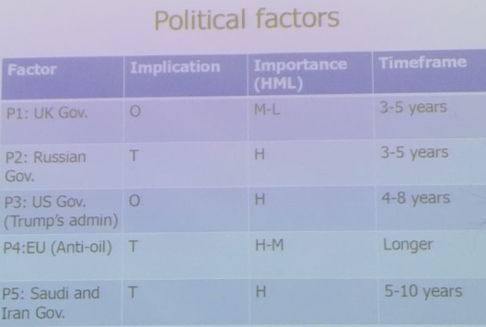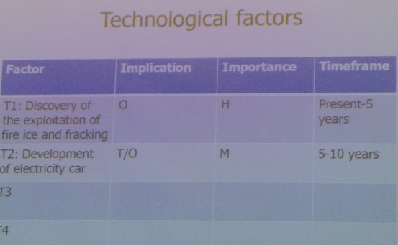 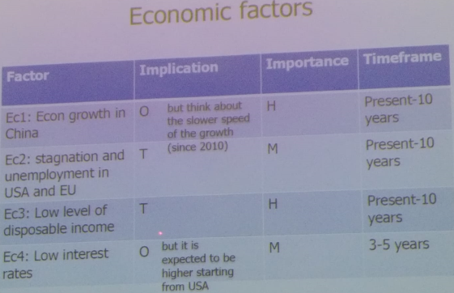 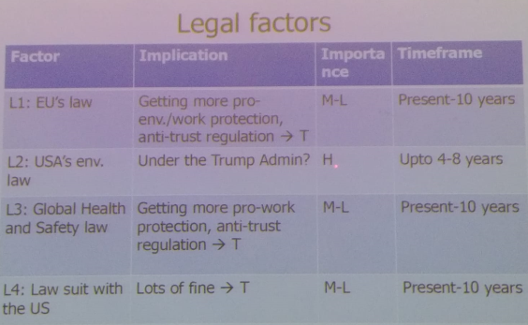…etc.

Important note about ARNA regulations

The regulations specify that students must complete every assessment component contributing to the modules on their programme. This applies to all forms of assessment as defined in the module descriptor. Please note that:

- if any assessment component is not completed, students will be failed in the module even if the module pass mark has been achieved;
- if the requirements for referral specified in section 5 of ARNA¹ are met, a resit opportunity will be given;
- if unable to complete an assessment component because of extenuating circumstances, students should follow the procedure described in the Student Guide to Extenuating Circumstances¹.

This change was approved by Academic Board on 12 October 2009 in consultation with the Students’ Union. Students should consult their Programme Leader or Guidance Tutor if they have any queries. Independent advice and support is also available from the Students’ Union Advice & Representation Centre or from a student adviser in Student Services.

Word Count
The word count is declared on the front page of your assignment. The word count does not include title page, contents page, glossary, tables, figures, illustrations, reference list, bibliography and appendices.

Summarising and compressing the information in your assignment into the word limit is one of the skills that students are expected to acquire, and demonstrate as part of the assignment process.

Word limits and penalties for assignments

If the assignment is within +10% of the stated word limit no penalty will apply. However, if the word limit exceeds the +10% limit, 10% of the mark provisionally awarded to the assignment will be deducted. For example: if the assignment is worth 70% but is above the word limit by more than 10%, a penalty of 7% will be imposed, giving a final mark of 63%.

Referencing your work

The APA method of referencing uses the author's name and the date of the publication. In-text citations give brief details of the work you are referring to in your text. For example:

Coutu (2009) found that every team needs a deviant There are many examples of where teams go wrong (Coutu, 2009)

References are listed at the end of the text in alphabetical order by the author's name. The general format of an electronic journal reference in the APA style is shown below:

Coutu, D. (2009). Why Teams Don't Work. Harvard Business Review, 87(5), 98-105. Retrieved from EBSCO http://searchebscohost.com

Author/s name and initials are listed first, followed by year of publication in brackets. Then there is the title of article and the journal where the article appears, which is in italics. Then state the volume and issue number (in brackets) along with the pages where article can be located. Finally add the name of the database, followed by the web address. Wherever possible use the homepage URL rather than the full and extended web address.

Plagiarism and Cheating

Your attention is drawn to the University’s stated position on plagiarism. THE WORK OF OTHERS, WHICH IS INCLUDED IN THE ASSIGNMENT MUST BE ATTRIBUTED TO ITS SOURCE (a full bibliography and/or a list of references must be submitted as prescribed in the assessment brief).

Please note that this is intended to be an individual piece of work. Action will be taken where a student is suspected of having cheated or engaged in any dishonest practice. Students are referred to the University regulations on plagiarism and other forms of academic irregularity. Students must not copy or collude with one another or present any information that they themselves have not generated.

Student name: |  |  | Marked by:
 | 0-20%  Fail | 21 – 39%  Fail | 40 – 59%  Pass | 60 – 69%  Commendation | 70 – 100%  Distinction
Section A (introduction) – 10% | Poor use of references  Poor discussion of the importance of analysing the business environment  Poor introduction  Poor structure | Insufficient use of references  Poor discussion of the importance of analysing the business environment  Limited introduction  Limited structure | Sufficient use of references  Adequate discussion of the importance of analysing the business environment  Adequate introduction  Adequate structure | Commendable use of references  Commendable discussion of the importance of analysing the business environment  Commendable introduction  Commendable structure | Excellent use of references  Excellent discussion of the importance of analysing the business environment  Excellent introduction  Excellent structure
Section A (introduction) – 10% | 0-2 marks | 3 marks | 4-5 marks | 6 marks | 7-10 marks
Section B (Use of framework)- 70% | Poor use of framework  Data collected is inappropriate or irrelevant to the context  No attempt at analysis or evaluation  Poor structure | Limited use of framework  Data collected is appropriate and relevant but is descriptive  Limited attempt at analysis or evaluation  Inadequate structure | Good use of framework  Data collected is appropriate and relevant and some attempt made to discuss implications  Good attempt at analysis or evaluation  Good structure | Commendable use of framework  Data collected is appropriate and relevant and commendable attempt made to discuss implications  Commendable attempt at analysis or evaluation  Commendable structure | Excellent use of framework  Data collected is appropriate and relevant and excellent attempt made to discuss implications  Excellent attempt at analysis or evaluation  Excellent structure
 | 0-14 marks | 15-27 marks | 28-41 marks | 42-48 marks | 49-70 marks
Section C (opportunities) 20% | No opportunities have been identified  No synthesis  Very poor structure | Few opportunities have been identified  Limited synthesis  Poor structure | Good range of opportunities have been identified  Good synthesis  Good structure | Commendable range of opportunities have been identified  Commendable synthesis  Commendable structure | Excellent range of opportunities have been identified  Excellent synthesis  Excellent structure
Section C (opportunities) 20% | 0-4 marks | 5-7 marks | 8-11 marks | 12-13 marks | 14-20 marks

